Assignment 3: Supply Chain Management DApp
Student Name: Aysha Asmat
Network: Polygon Amoy Testnet

1. Project Overview
This project implements a decentralized application (DApp) for Supply Chain Management on the Polygon Amoy network. The system tracks products through four key roles: Manufacturer, Distributor, Retailer, and Customer. It ensures transparency and a tamper-proof audit trail for every product registered in the system.

2. Technical Implementation
Smart Contract Design
- Roles: Implemented using access control logic to distinguish between the Manufacturer (who can register products) and other participants.
- Data Structures: A Product struct stores the unique ID, Name, Description, Current Owner, and Status (Manufactured, In Transit, Delivered).
- Functions: * registerProduct: Restricted to the Manufacturer.
  - transferOwnership: Updates the current owner and status as the product moves through the chain.
  - viewHistory: Allows users to view the audit trail.
Development Environment
- Framework: Hardhat was used for compilation and deployment.
- Network Configuration: Configured in hardhat.config.cjs to point to the Polygon Amoy RPC URL.
- Frontend: Built with React and ethers.js to interact with the blockchain.
3. Steps Performed

Step 1: Compilation
The smart contract was compiled using Hardhat to generate the ABI and Bytecode.
- Command: npx hardhat compile
- 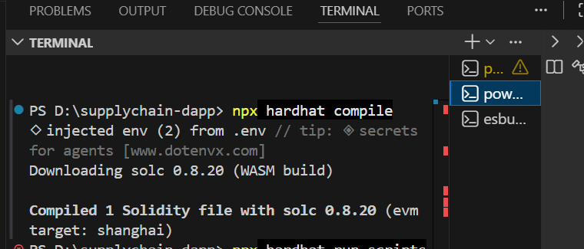

Step 2: Deployment
The contract was deployed to the Polygon Amoy Testnet using a custom deployment script.
- Command: npx hardhat run scripts/deploy.cjs --network amoy
- 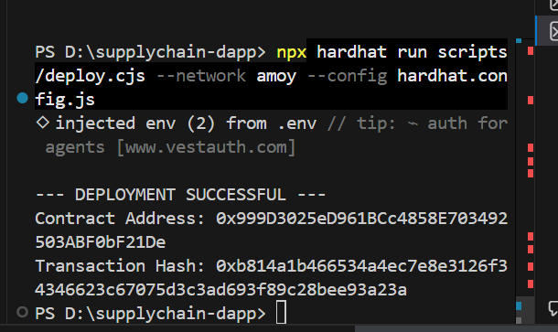

Step 3: Verification
The transaction was verified on the Polygonscan Block Explorer to confirm its status on the blockchain.
- 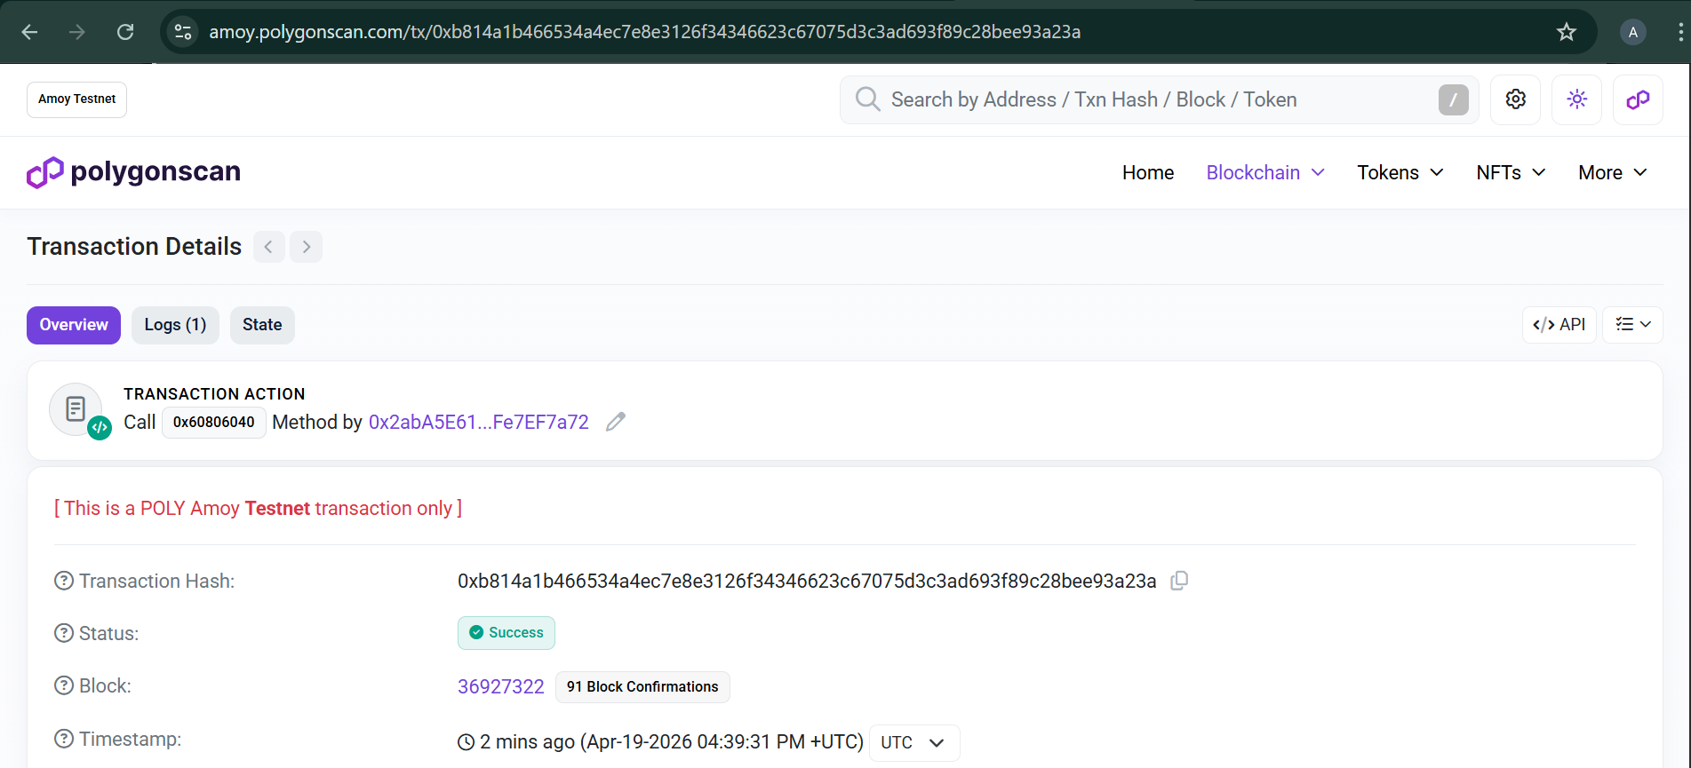
- 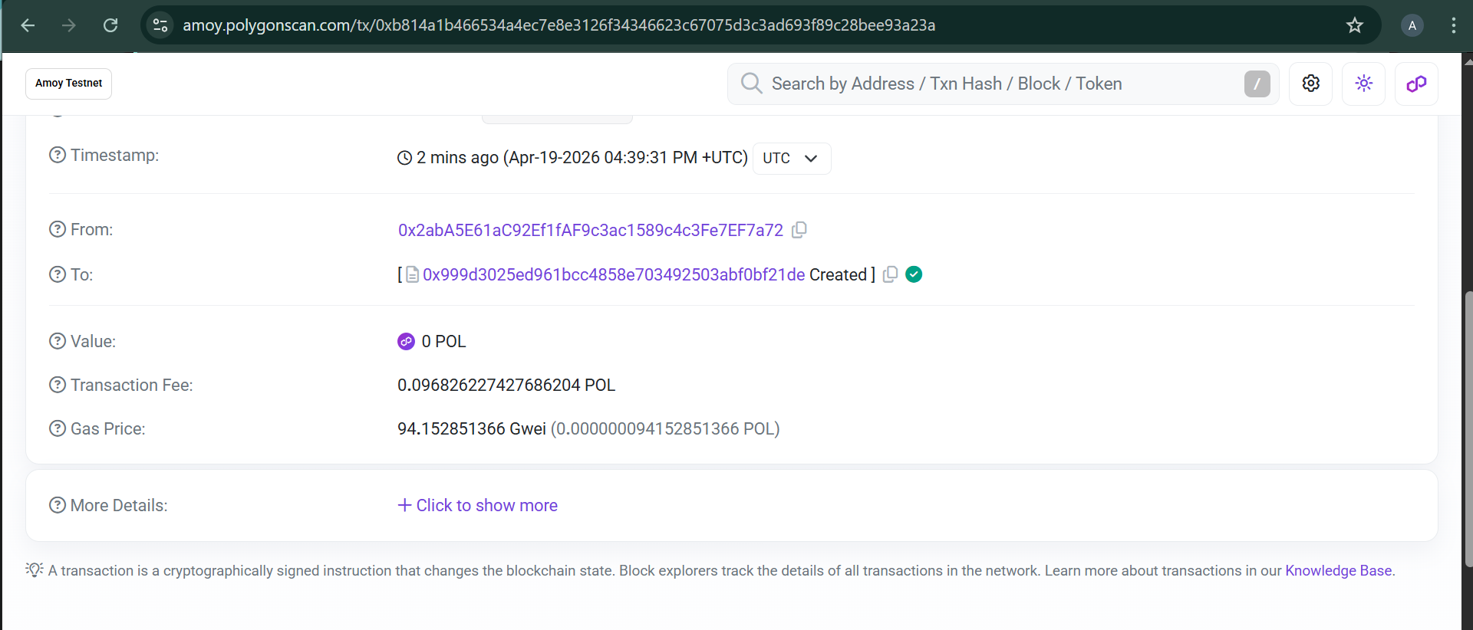
- 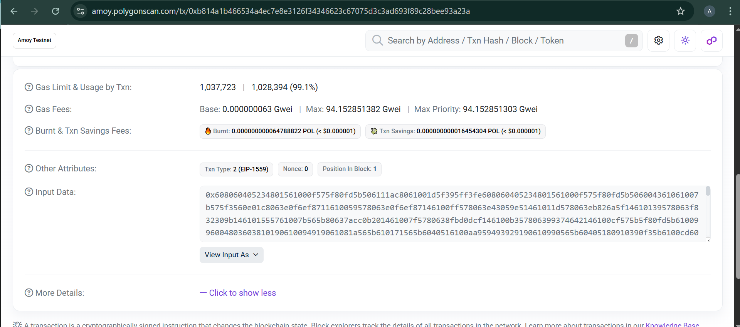

Step 4: Frontend Integration
The React application was connected to the deployed contract address. My name is displayed on the header of the application as per requirements.
- 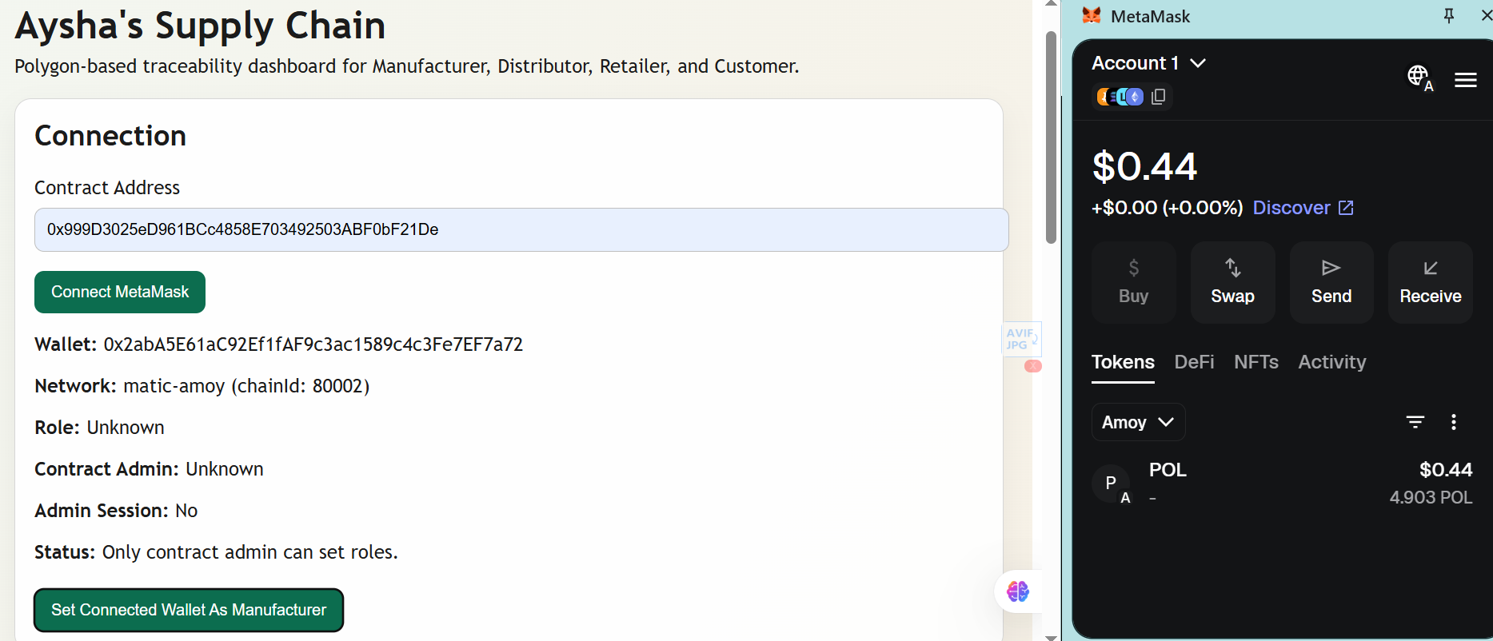
- 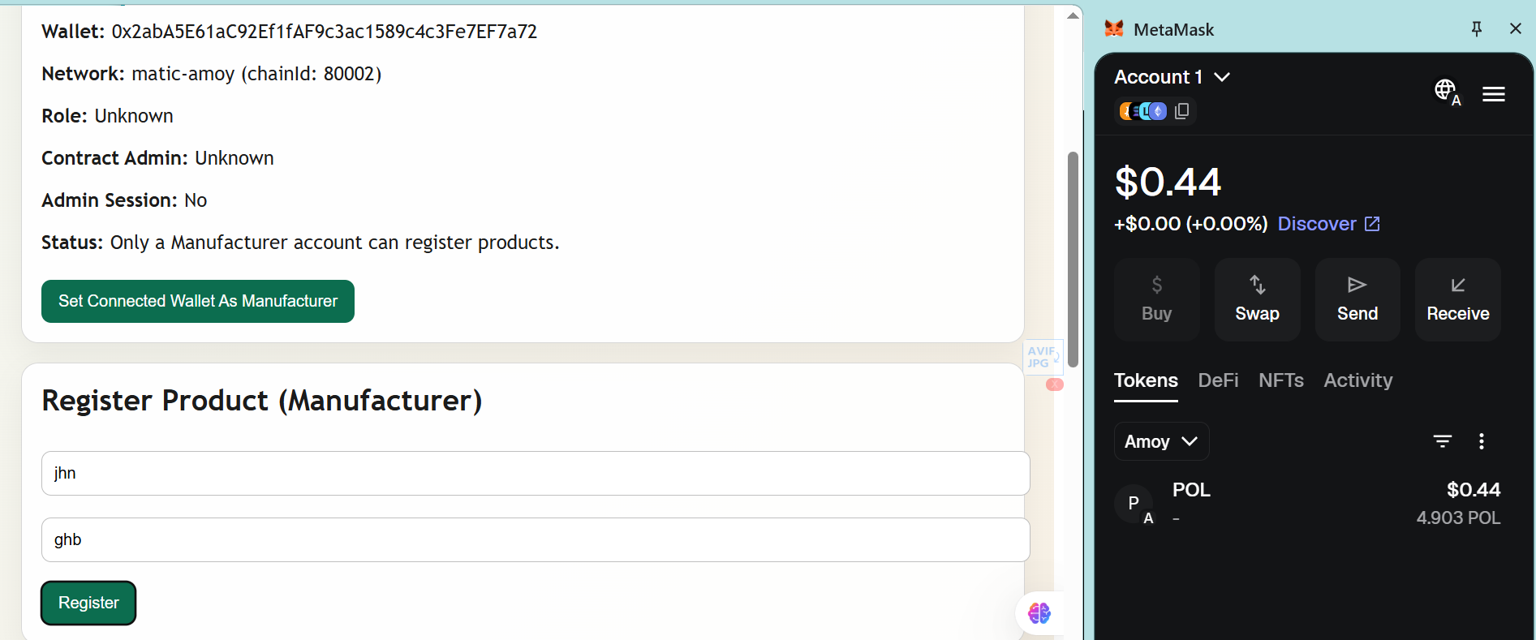
- 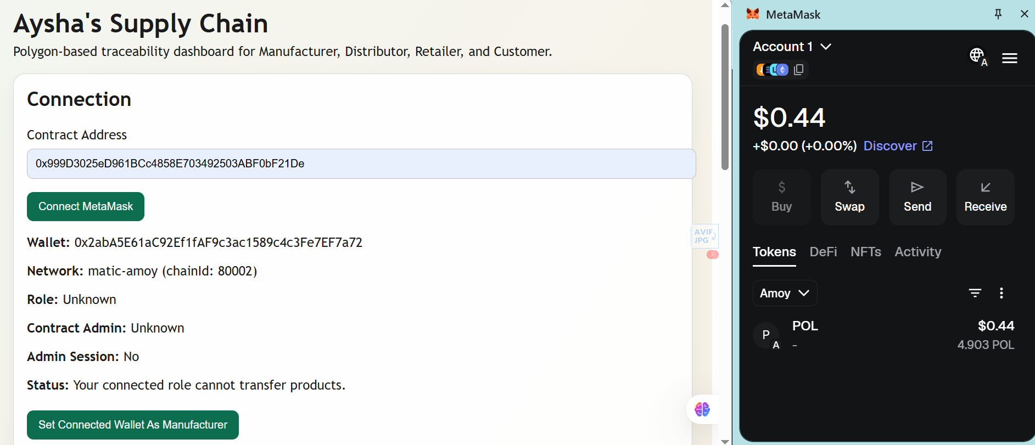
- 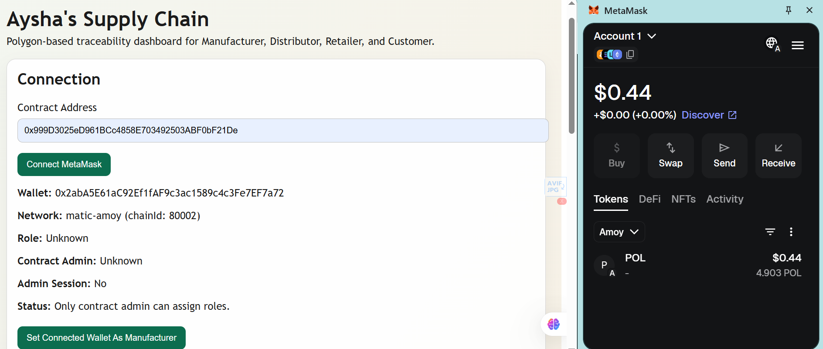
- 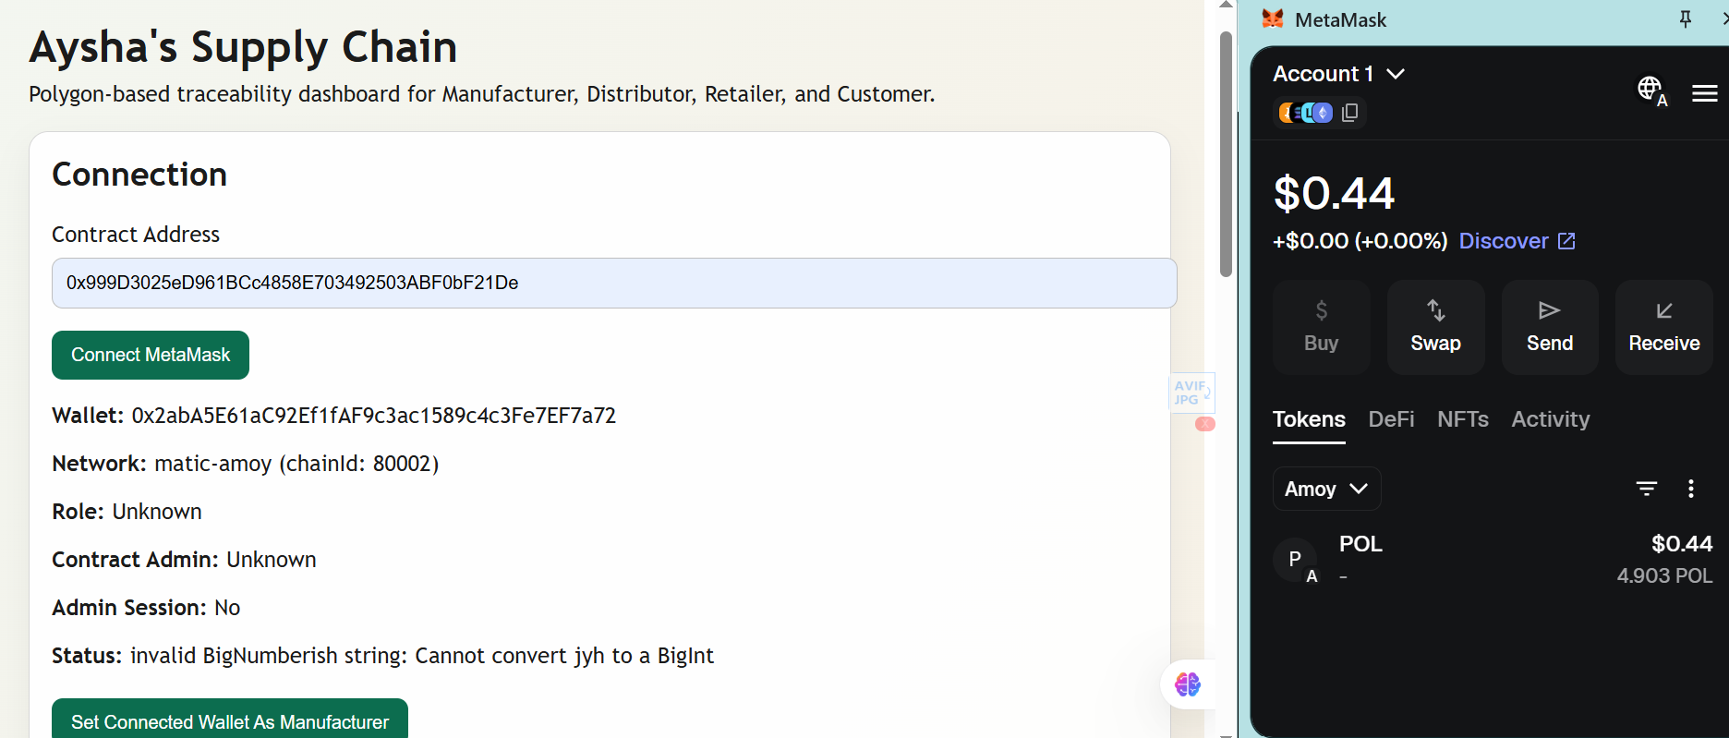
- 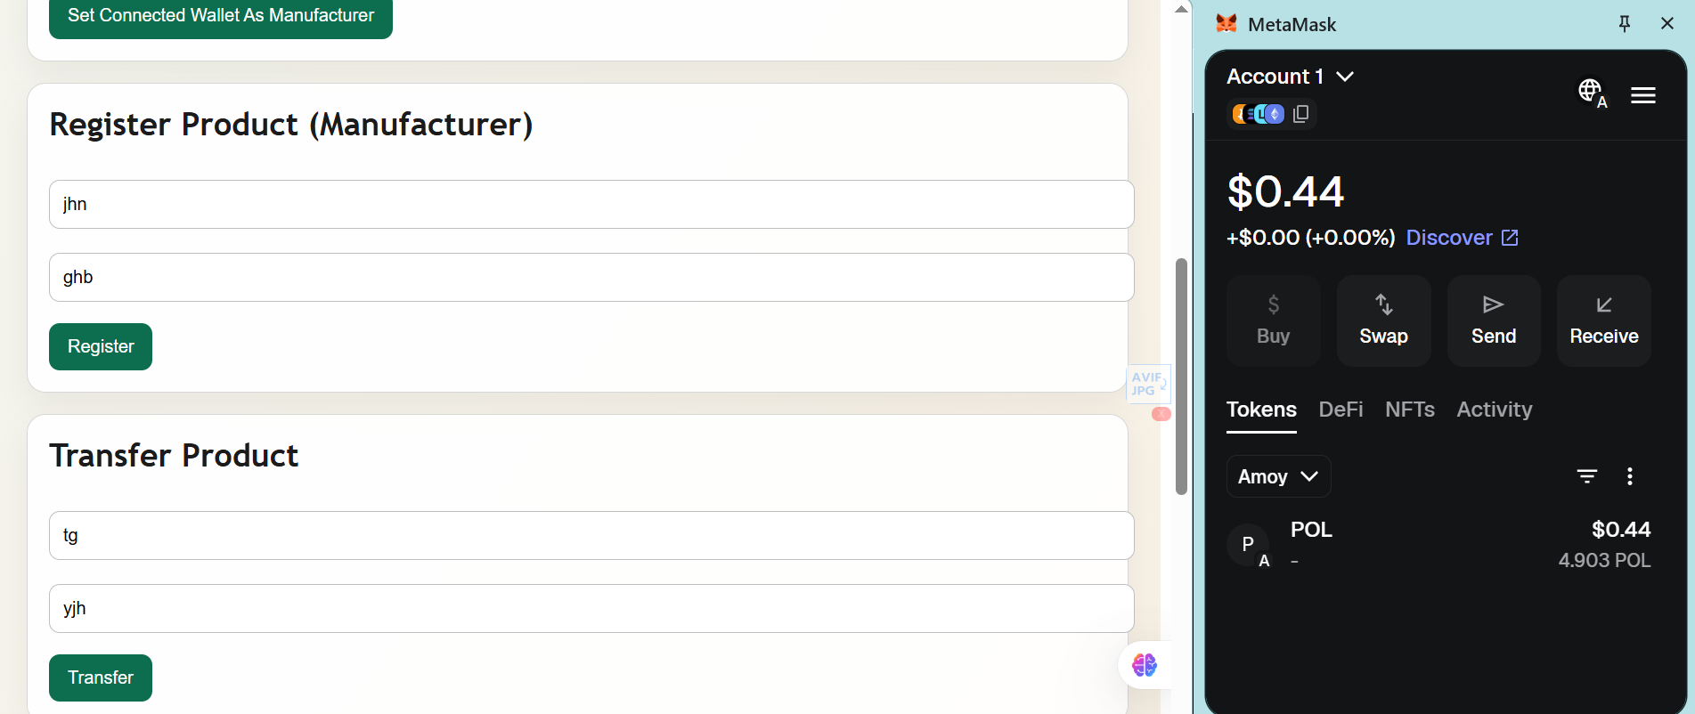
- 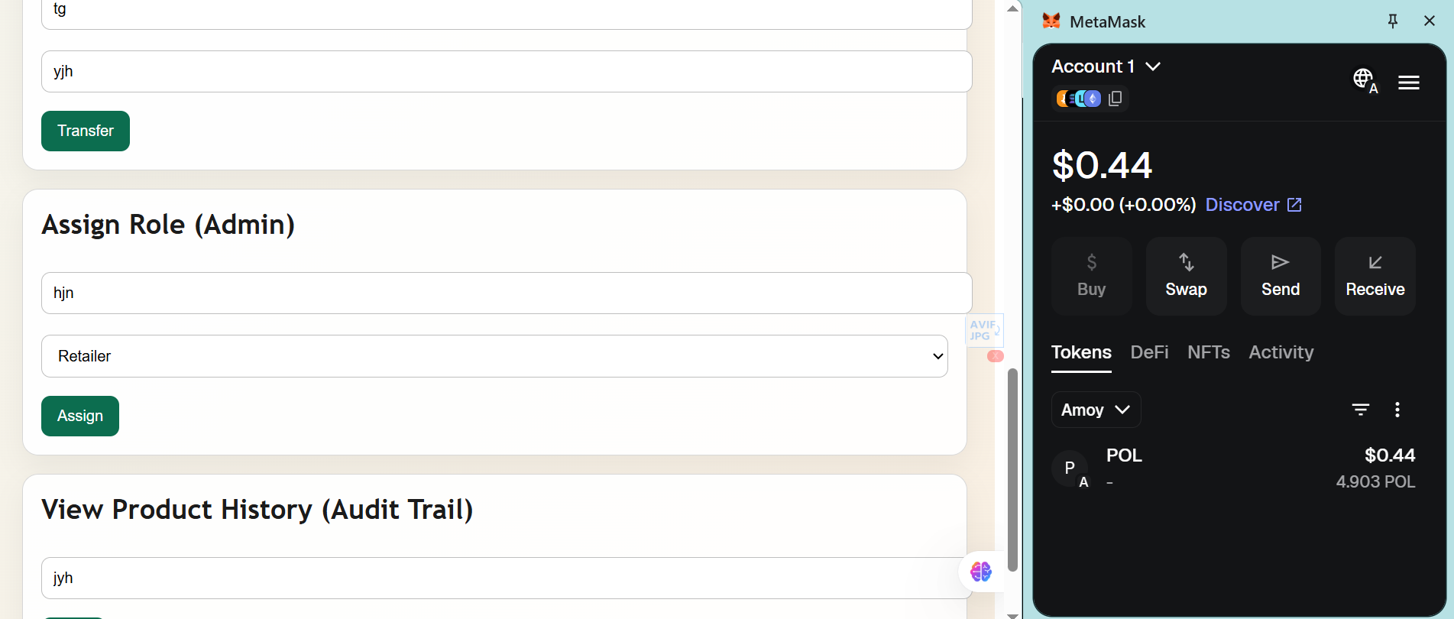

4. Deliverables
- Contract Address: 0x999D3025eD961BCc4858E703492503ABF0bF21De
- Transaction Hash: 0xb814a1b466534a4ec7e8e3126f34346623c67075d3c3ad693f89c28bee93a23a
- Source Code: Included in the project directory (.sol file)
- Frontend Files: Included in the src/ directory
5. System Workflow
- Manufacturing: The Manufacturer registers a product on the DApp, creating a unique ID on the blockchain.
- Distribution: Ownership is transferred to the Distributor; the status changes to "In Transit."
- Retail: The Retailer receives the product and acknowledges ownership.
- Consumption: The final Customer purchases the product, and the status is updated to "Delivered."
- Audit: Anyone can use the "View History" function to see the entire path the product took from the factory to the consumer.

